Travel agency

[https://katarinaict.github.io/travelagency57-19/#](https://katarinaict.github.io/travelagency57-19/)

Modul: Web programiranje

Predmet: Web programiranje 1

Autor: Katarina Milicevic

Broj indexa: 57/19

Contents

1. Uvod 3

1.1 Korisceni programski jezici i tehnologije 3

1.2 Opis funkcionalnosti 3

1.3 Template 4

2. Organizacija sajta 8

2.1 Oranizaciona sema 8

2.2 Mapa sajta 8

2.3 Slike stranica I opisi 8

2.3.1 Home 8

3.2.2 Destination 10

3.2.3 Packages 11

3.2.4 Special offer 12

3.2.5 Blog 12

3.2.6 Subscription 13

3. Kodovi 14

3.1 HTML 14

3.2 CSS 27

3.3 JavaScript 37

3.4 Jquery 44

# Uvod

## Korisceni programski jezici i tehnologije

* HTML
* CSS
* Bootstrap
* JavaScript
* Jquery
* Visual Studio Code

## Opis funkcionalnosti

Na sajtu je moguce promeniti boju linka prelaskom misa preko njega. Prilagodjen je za sve uredjaje. Pri menjanju rezolucije ekrana, na uredjajima manje sirine, pojavljuje se ikonica hamburgera umesto standardne navigacije, a klikom na njega prikazuje se meni. Klikom na bilo koji link iz navigacije, korisniku se blagim spustanjem sadrzaja prikazuje zeljeni sadrzaj iz index stranice. Stavke koje se ponavljaju vise puta, uradjene su dinamicki preko JavaScript-a. Podaci koji se unose u formu prolaze test ispravnosti, i u skladu sa tim da li su podaci uneti ispravno ili ne, korisnik dobija povratnu informaciju o tome. Takodje, komentari se smenjuju posle odredjenog vremena.

## Template

Template nije preuziman sa drugih stranica. Snimak stranice i struktura blokova u nastavku.

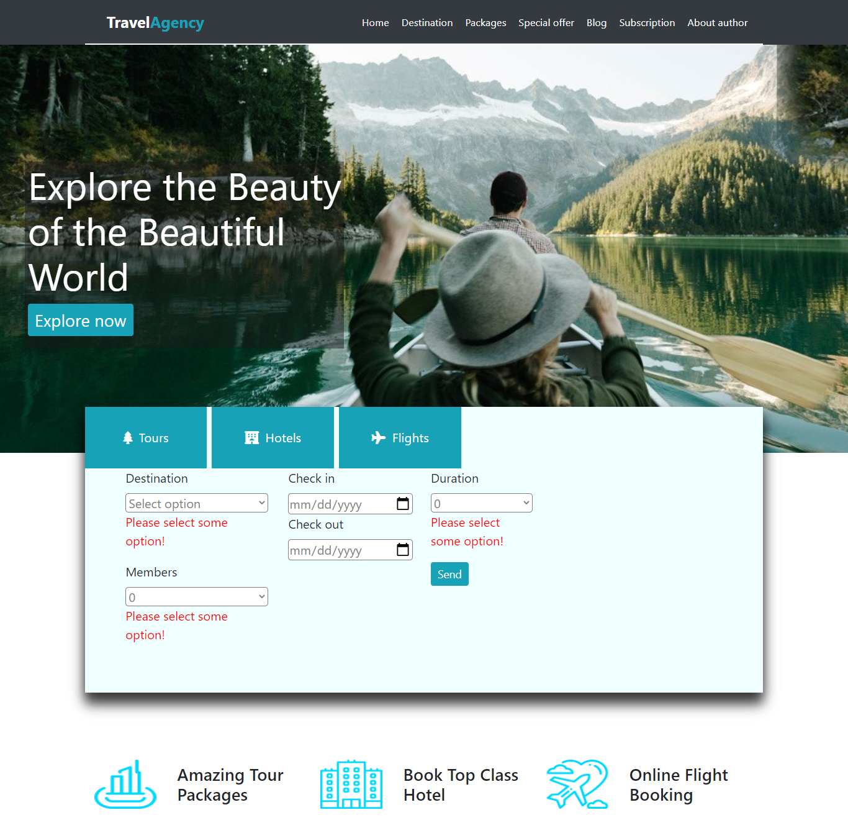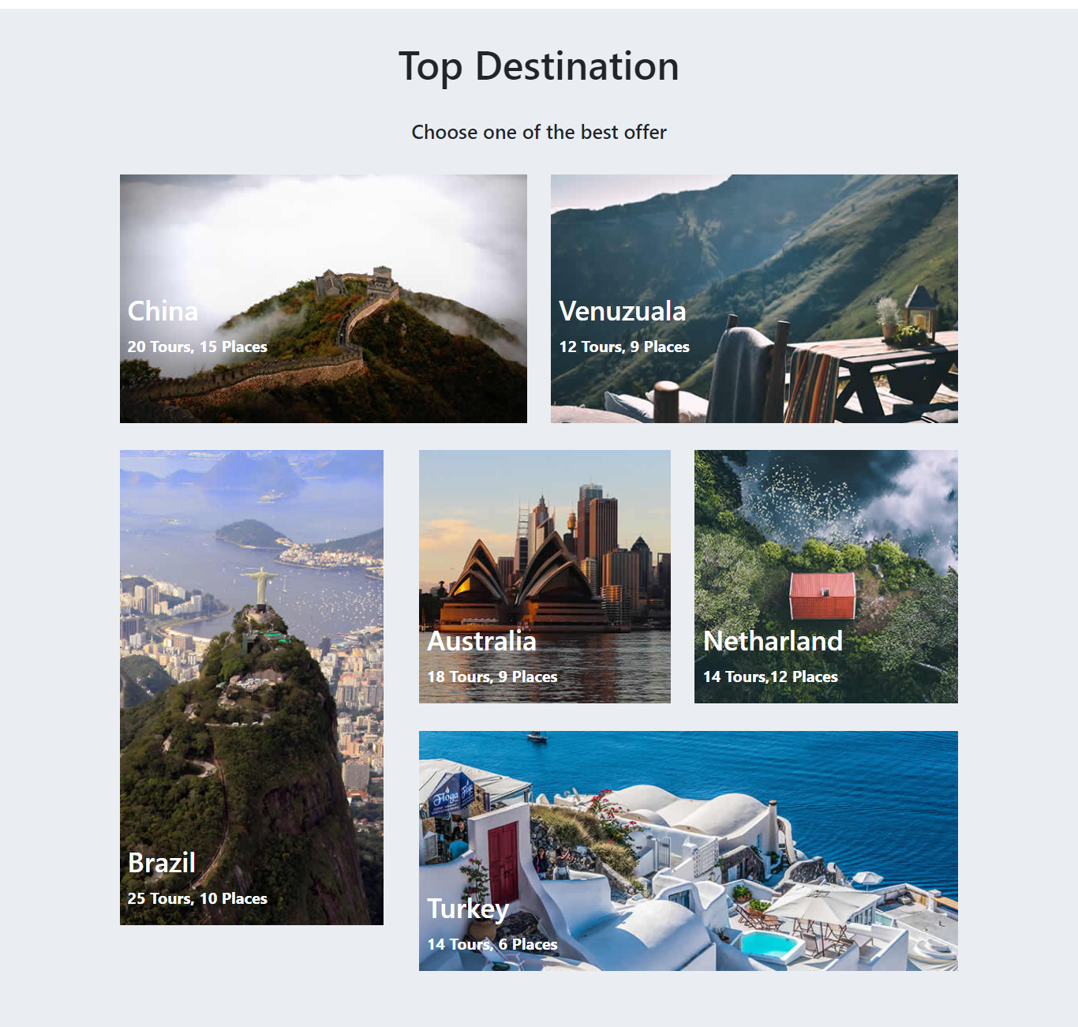

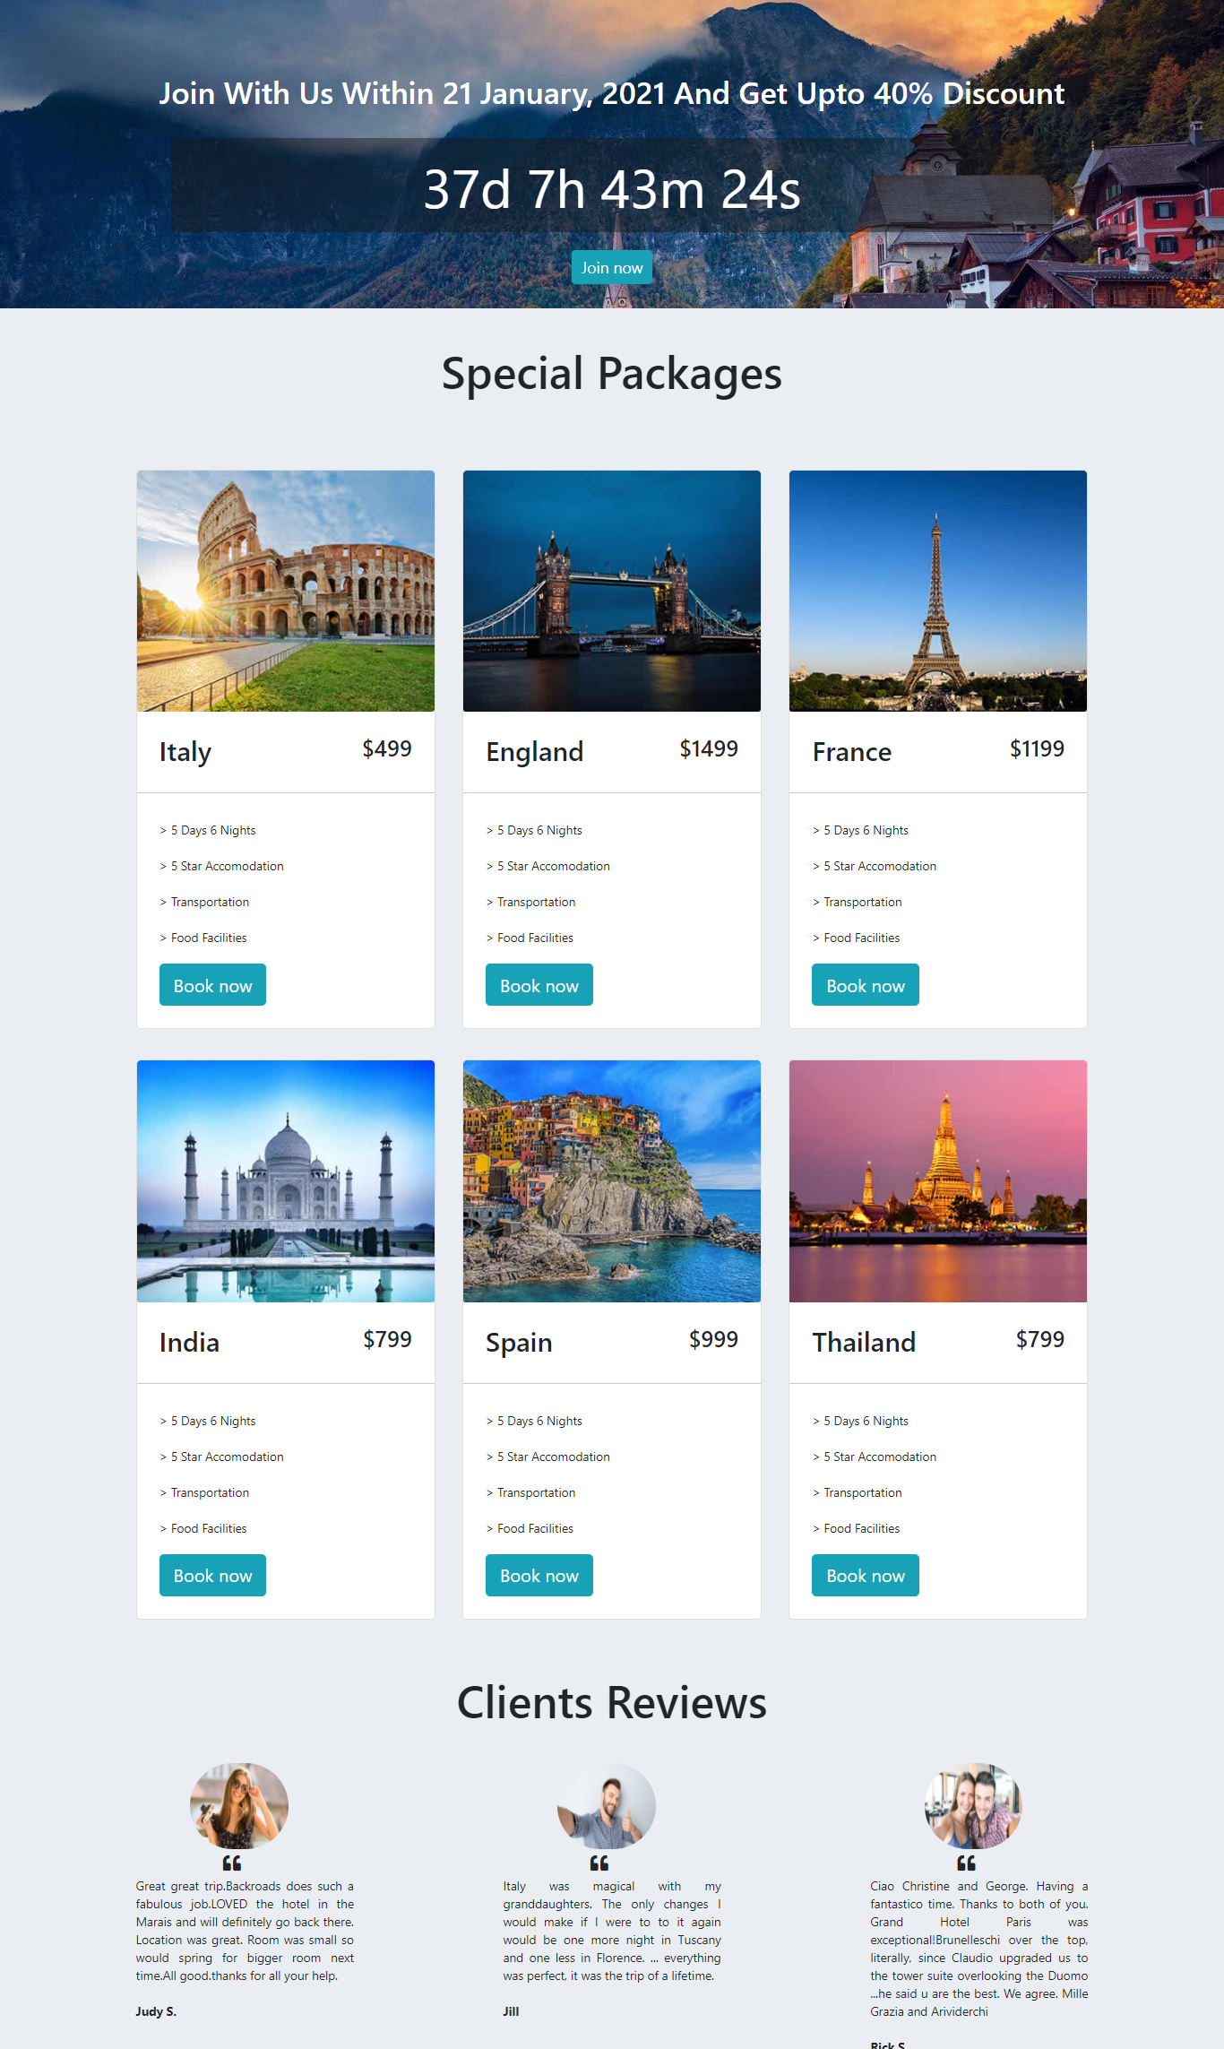

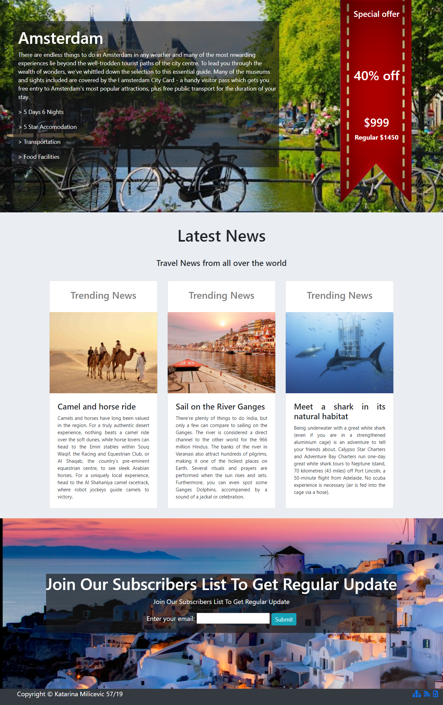

# Organizacija sajta

## Oranizaciona sema

Ovaj sajt sadrzi jednu stranicu. (index.html)

## Mapa sajta

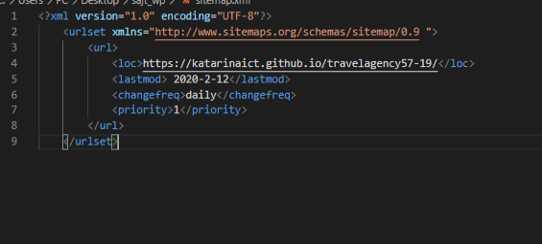

## Slike stranica I opisi

Sajt sadrzi samo jednu stranicu koja je podeljena na vise funkcionalnih sekcija (Home, Destination, Packages, Special offer, Blog, Subscription, About autor- vodi ka linku ranije napravljenog portfolia).

### Home

U okviru stranice Home, nalazi se dinamicki ispisan meni, koji klikom na odredjeni link korisnika, blagim

prelazom preko ostalog sadrzaja, vodi ka zeljenoj sekciji. Takodje tu se nalazi i slogan stranice uz dugme Explore now, koji korisnika vodi da istrazi ponudu same Agencije. Pored svega toga, tu je i validaciona forma, koja korisniku pruza mogucnost da zakaze svoje putovanje, ukoliko je podatke korektno uneo, dok ukoliko nije, prikazuje mu se greska tamo gde postoji.



### 3.2.2 Destination

Sekcija Destination zamisljena je samo kao galerija koja bi privukla paznju posmatraca i probudila zelju u njemu da otputuje na neku od lokacija. Ispod nje se nalazi jedinstvena ponuda koja traje do odredjenog datuma i tu je postavljen i tajmer koji pokazuje koliko jos vremena korisnik ima do isteka ponude.

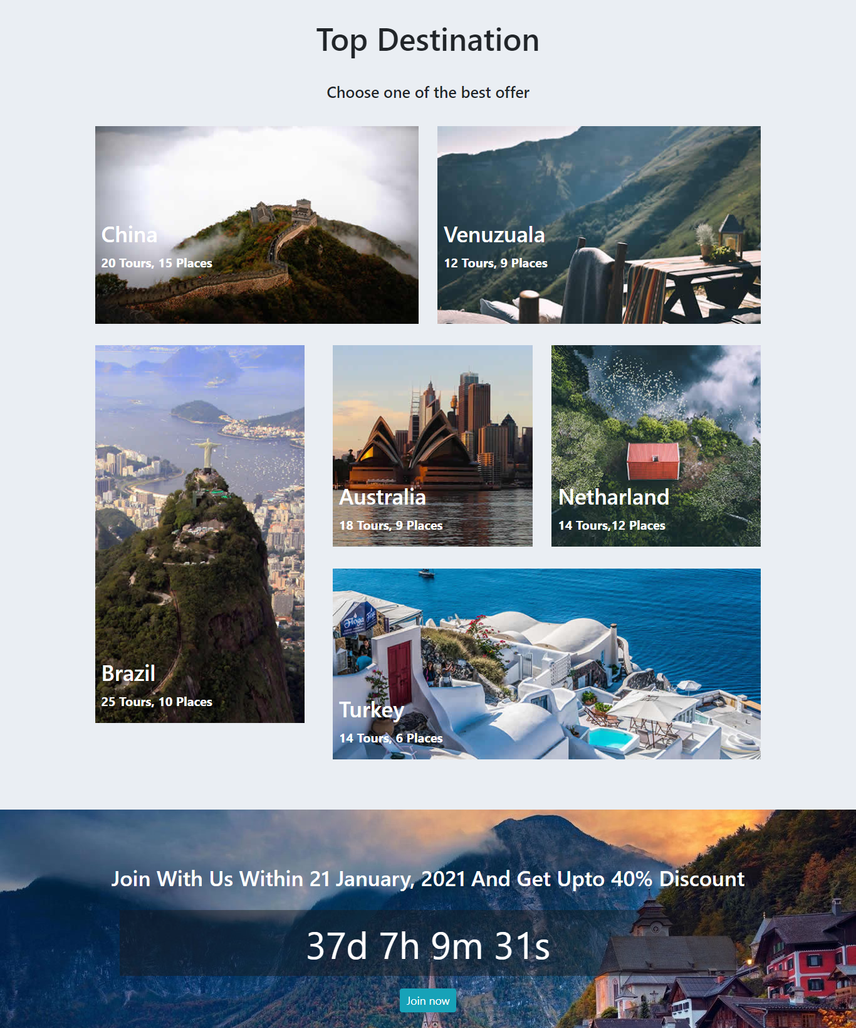

### 3.2.3 Packages

U okviru sekcije Packages su dinamicki prikazane kartice koje prikazuju razlicite ponude Agencije, u okviru svake kartice nalazi se dugme Book now koje vodi ka formi iz sekcije Home. Ispod ponude se nalaze komentari korisnika osmisljeni tako da se smene nakon odredjenog vremena.

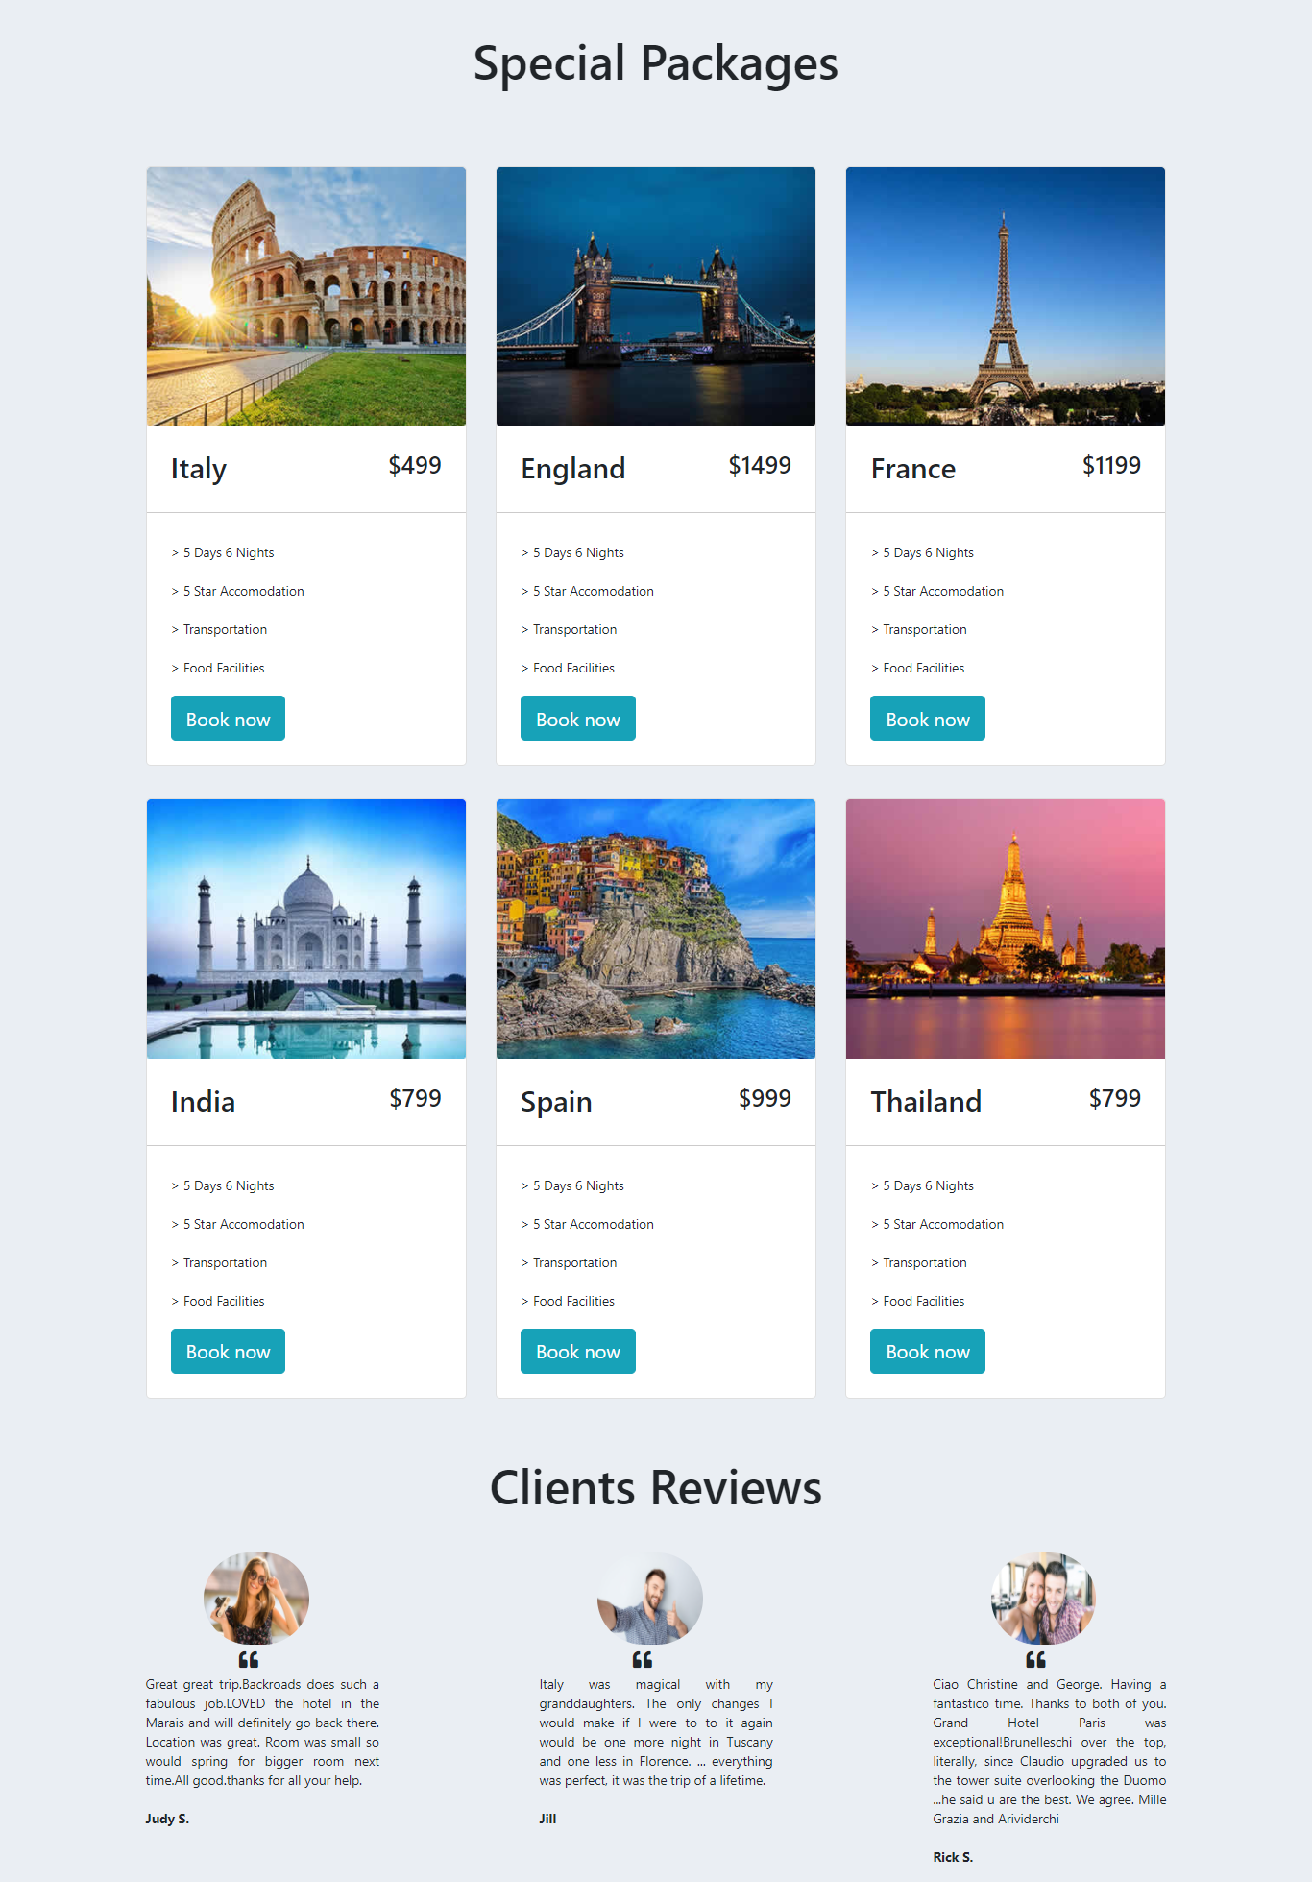

### 3.2.4 Special offer

Sekcija ne sadrzi nikakve posebne funkcionalnosti, predstavlja jednu od istaknutih ponuda.

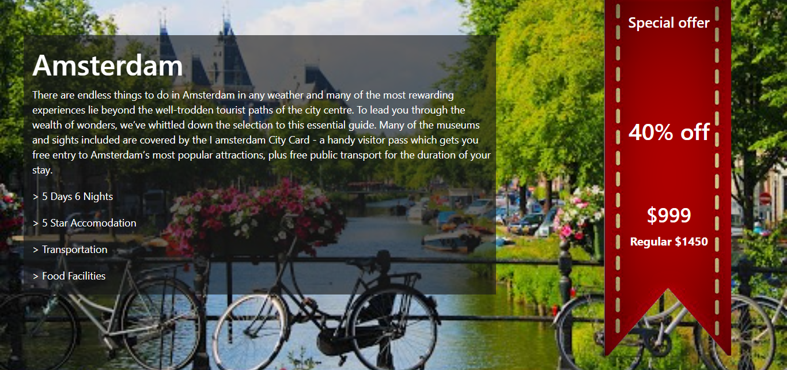

### 3.2.5 Blog

Sekcija Blog sadrzi dinamicki ispisane kartice, namenjene da prikazu neobicnije ponude korisnicima u nadi da ce ih zainteresovati da odaberu bas nesto sa spiska ponude njihove agencije.

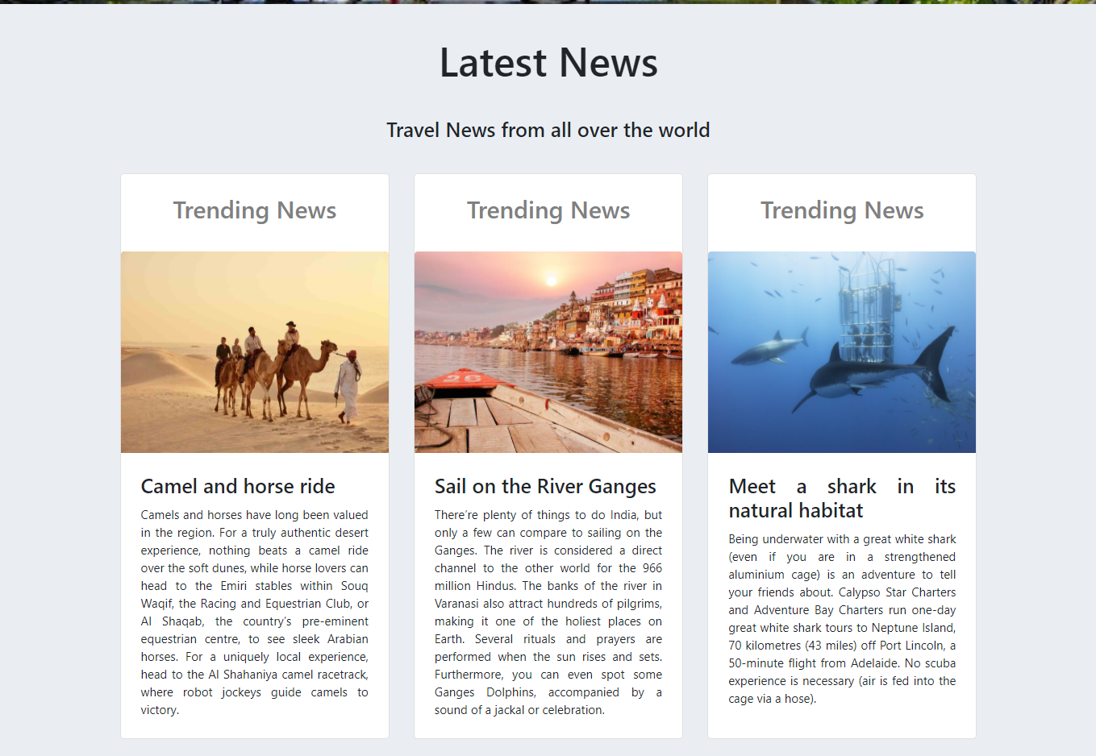

### 3.2.6 Subscription

Sekcija sadrzi formu za prijavu mejla, kojoj je takodje uradjena validacija, i ukoliko dodje do greske pri prijavi korisnik ce biti obavesten.

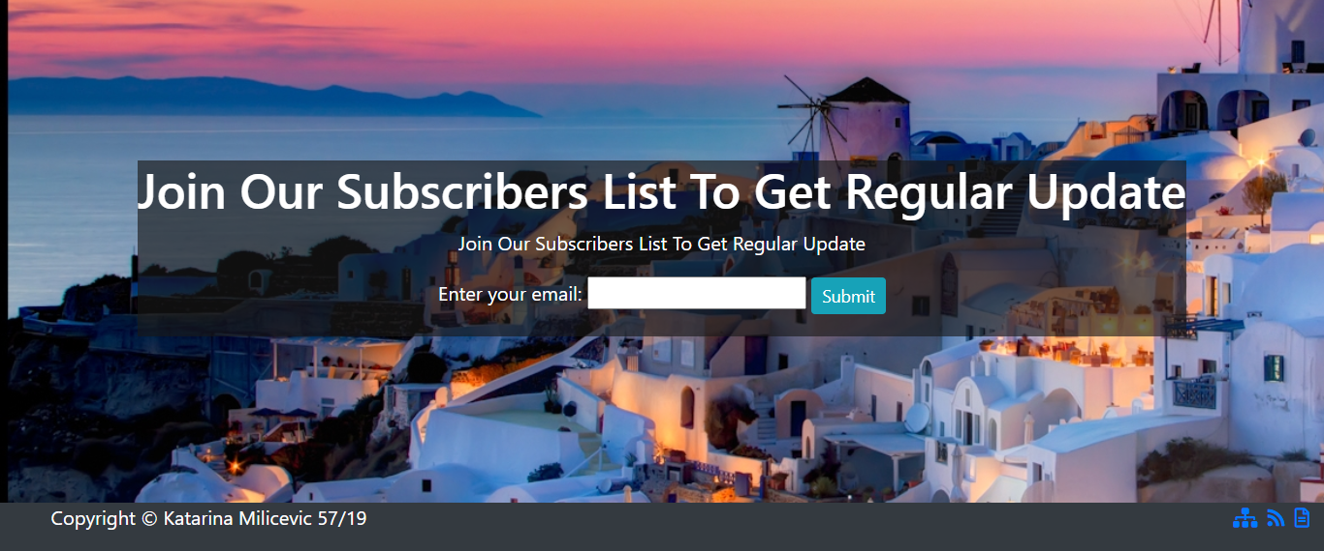

# Kodovi

## HTML

1. <!DOCTYPE html>
2. <html>
3. <head>
4. <script src="https://code.jquery.com/jquery-3.3.1.slim.min.js" integrity="sha384-q8i/X+965DzO0rT7abK41JStQIAqVgRVzpbzo5smXKp4YfRvH+8abtTE1Pi6jizo" crossorigin="anonymous"></script>
5. <script src="https://cdnjs.cloudflare.com/ajax/libs/popper.js/1.14.7/umd/popper.min.js" integrity="sha384-UO2eT0CpHqdSJQ6hJty5KVphtPhzWj9WO1clHTMGa3JDZwrnQq4sF86dIHNDz0W1" crossorigin="anonymous"></script>
6. <link rel="stylesheet" href="https://stackpath.bootstrapcdn.com/bootstrap/4.3.1/css/bootstrap.min.css" integrity="sha384-ggOyR0iXCbMQv3Xipma34MD+dH/1fQ784/j6cY/iJTQUOhcWr7x9JvoRxT2MZw1T" crossorigin="anonymous">
7. <script src="https://stackpath.bootstrapcdn.com/bootstrap/4.3.1/js/bootstrap.min.js" integrity="sha384-JjSmVgyd0p3pXB1rRibZUAYoIIy6OrQ6VrjIEaFf/nJGzIxFDsf4x0xIM+B07jRM" crossorigin="anonymous"></script>
8. <title>Travel agency</title>
9. <meta name="viewport" content="width=device-width, initial-scale=1">
10. <link rel="stylesheet" type="text/css" href="css/style.css"/>
11. <meta charset="UTF-8"/>
12. <script src="https://kit.fontawesome.com/3b6146fca4.js" crossorigin="anonymous"></script>
13. <meta name="home" content="Explore, Travel">
14. <meta name="destination" content="China, Venuzuala, Brazil, Australia, Netharland, Turkey">
15. <meta name="packages" content="Italy, England, France, India,Spain,Thailand">
16. <meta name="offer" content="Amsterdam">
17. <meta name="blog" content="Trending News,news, camel, horse, travel, river, shark">
18. <meta name="subs" content="subscription, join, mail">
19. <script src="https://code.jquery.com/jquery-3.5.1.min.js"
20. integrity="sha256-9/aliU8dGd2tb6OSsuzixeV4y/faTqgFtohetphbbj0="
21. crossorigin="anonymous"></script>
22. <script src="https://code.jquery.com/jquery-1.5.1.min.js" integrity="sha256-dkuenzrThqqlzerpNoNTmU3mHAvt4IfI9+NXnLRD3js=" crossorigin="anonymous"></script>
23. <script src="js/jquery.js"></script>
25. </head>
26. <body>
27. <div id="home">
28. <div class="container-fluid bg-dark" id="container-nav">
29. <div class="row" id="row">
30. <nav class="navbar navbar-expand-lg navbar-light " id="nav">
31. <a class="navbar-brand col-lg-3 col-md-7 col-sm-1" id="logo" href="#"><b>Travel<span class="text-info">Agency</span></b></a>
32. <button class="navbar-toggler" type="button" data-toggle="collapse" data-target="#navbarNav" aria-controls="navbarNav" aria-expanded="false" aria-label="Toggle navigation">
33. <span class="navbar-toggler-icon"></span>
34. </button>
35. <div class="collapse navbar-collapse col-lg-9 navRight" id="navbarNav">
36. <ul class="navbar-nav" id="ulList">
38. </ul>
39. </div>
40. </nav>
41. </div>
42. </div>
43. <div class="jumbotron d-flex align-items-center" id="jumb">
44. <div id="slajder-text">
45. <h1 class="display-4" ><b>Explore the Beauty of the Beautiful World</b></h1>
46. <p class="lead">
47. <a class="btn btn-info btn-sm" href="#destination" role="button">Explore now</a>
48. </p>
49. </div>
50. </div>
51. <div id="ponuda">
52. <div id="btn">
53. <div class="btn-group-lg" role="group" aria-label="Second group">
54. <button type="button " class="btn btn-info" data-formular="#tours"><i class="fas fa-tree"></i>Tours</button>
55. <button type="button " class="btn btn-info" data-formular="#hotels"><i class="fas fa-hotel"></i>Hotels</button>
56. <button type="button" class="btn btn-info"  data-formular="#flights"><i class="fas fa-plane"></i>Flights</button>
57. </div>
58. <div class="col-lg-12 d-flex justify-content-center" id="rodForma">
59. <form id="tours" class="forma aktivan" action="/action_page.php">
60. <div class="forma1">
61. <label>Destination</label>
62. <select  id="destlist">
63. <option value="Select option">Select option</option>
64. <option value="China">China</option>
65. <option value="Venezuala">Venezuala</option>
66. <option value="Brazil">Brazil</option>
67. <option value="Australia">Australia</option>
68. <option value="Netharland">Netherland</option>
69. <option value="Turkey">Turkey</option>
70. </select></br>
71. <p id="destprovera"></p>
72. <label>Members</label>
73. <select id="destmem">
74. <option value="0">0</option>
75. <option>1</option>
76. <option>2</option>
77. <option>3</option>
78. <option>4</option>
79. <option>5</option>
80. </select></br>
81. <p id="memprovera"></p>
82. </div>
83. <div class="forma2">
84. <label>Check in</label></br>
85. <input type="date" id="checkin" name="checkin" class="date"></br>
86. <p id="checkinprov"></p>
87. <label>Check out</label></br>
88. <input type="date" id="checkout" name="checkout" class="date"></br>
89. <p id="checkoutprov">
90. </div>
91. <div class="forma3">
92. <label>Duration</label>
93. <select id="destdure">
94. <option>0</option>
95. <option>3</option>
96. <option>5</option>
97. <option>10</option>
98. <option>15</option>
99. <option>30</option>
100. </select></br>
101. <p id="destdur"></p>
102. <input type="button" class="btn btn-info btn-sm" value="Send" onclick="provera1()">
103. </div>
104. <div class="cleaner"></div>
105. </form>
106. <form id="hotels" class="forma">
107. <div class="forma1">
108. <label>Destination</label>
109. <select id="desthot">
110. <option>Select option</option>
111. <option>China</option>
112. <option>Venezuala</option>
113. <option>Brazil</option>
114. <option>Australia</option>
115. <option>Netherland</option>
116. <option>Turkey</option>
117. </select></br>
118. <p id="pdes"></p>
119. <label>Members</label>
120. <select id="hotmem">
121. <option>0</option>
122. <option>1</option>
123. <option>2</option>
124. <option>3</option>
125. <option>4</option>
126. <option>5</option>
127. </select></br>
128. <p id="memhot"></p>
129. </div>
130. <div class="forma2">
131. <label>Check in</label></br>
132. <input type="date" id="checkin1" name="checkin" class="date"></br>
133. <p id="checkinprov1"></p>
134. <label>Check out</label></br>
135. <input type="date" id="checkout1" name="checkout" class="date"></br>
136. <p id="checkoutprov1"></p>
137. </div>
138. <div class="forma3">
139. <label>Duration</label>
140. <select id="hotdur">
141. <option>0</option>
142. <option>3</option>
143. <option>5</option>
144. <option>10</option>
145. <option>15</option>
146. <option>30</option>
147. </select></br>
148. <p id="durhot"></p>
149. <input type="button" class="btn btn-info btn-sm" value="Send" onclick="provera2()">
150. </div>
151. <div class="cleaner"></div>
152. </form>
153. <form id="flights" class="forma" name="formafli">
154. <div class="forma1">
155. <input type="radio" value="Round Trip" name="rb" id="rb1"> Round Trip
156. <input type="radio" value="On way" name="rb" id="rb2"> On way</br>
157. <p id="radio"></p>
158. <label>Enter your location</label>
159. <select id="loc">
160. <option>Select option</option>
161. <option>Serbia</option>
162. <option>BiH</option>
163. <option>Croatia</option>
164. <option>Montenegro</option>
165. </select></br>
166. <p id="loca"></p>
167. <label>Going to</label>
168. <select id="go">
169. <option>Select option</option>
170. <option>China</option>
171. <option>Venezuala</option>
172. <option>Brazil</option>
173. <option>Australia</option>
174. <option>Netherland</option>
175. <option>Turkey</option>
176. </select></br>
177. <p id="going"></p>
178. </div>
179. <div class="forma2">
180. <label>Departure</label></br>
181. <input type="date" id="checkin2" name="checkin" class="date"></br>
182. <p id="checkinprov2"></p>
183. <label>Return</label></br>
184. <input type="date" id="checkout2" name="checkout" class="date"></br>
185. <p id="checkoutprov2"></p>
186. <label>Adults</label>
187. <select id="adul">
188. <option>0</option>
189. <option>1</option>
190. <option>2</option>
191. <option>3</option>
192. <option>4</option>
193. <option>5</option>
194. </select></br>
195. <p id="padul"></p></div>
196. <div class="forma3">
197. <label>Childs</label>
198. <select id="chil">
199. <option>0</option>
200. <option>1</option>
201. <option>2</option>
202. <option>3</option>
203. <option>4</option>
204. <option>5</option>
205. </select></br>
206. <p id="pchil"></p>
207. <label>Class</label>
208. <select id="clas">
209. <option>Select</option>
210. <option>A</option>
211. <option>B</option>
212. <option>C</option>
213. </select></br>
214. <p id="pclas"></p>
215. <input type="button" class="btn btn-info btn-sm" value="Send" onclick="provera3()" >
216. </div>
217. <div class="cleaner"></div>
218. </form>
219. </div>
220. </div>
221. </div>
222. <div class="container-fluid" id="container1">
223. <div class="row" id="slike_lista">
224. <div class="col-lg-4 col-md-4 col-sm-4 containerClass">
225. <div class="img1">
226. <img src="img/s1.png"/>
227. </div>
228. <div class="text1">
229. <h2>Amazing Tour Packages</h2>
230. </div>
231. <div class="cleaner"></div>
232. </div>
233. <div class="col-lg-4 col-md-4 col-sm-4 containerClass">
234. <div class="img1">
235. <img src="img/s2.png"/>
236. </div>
237. <div class="text1">
238. <h2>Book Top Class Hotel</h2>
239. </div>
240. <div class="cleaner"></div>
241. </div>
242. <div class="col-lg-4 col-md-4 col-sm-4 containerClass">
243. <div class="img1">
244. <img src="img/s3.png"/>
245. </div>
246. <div class="text1">
247. <h2>Online Flight Booking</h2>
248. </div>
249. <div class="cleaner"></div>
250. </div>
252. </div>
253. </div>
254. </div>
255. <div id="destination">
256. <div class="naslov">
257. <h1>Top Destination</h1></br>
258. <h5>Choose one of the best offer</h5>
259. </div>
260. <div class="omot">
261. <div class="container-fluid" id="containerImages">
262. <div class="row d-flex justify-content-between">
263. <div class="col-lg-6 col-sm-12 slika">
264. <div id="slika1">
265. <h3>China</h3>
266. <p><b>20 Tours, 15 Places</b></p>
267. </div>
268. </div>
269. <div class="col-lg-6 col-sm-12 slika">
270. <div id="slika2">
271. <h3>Venuzuala</h3>
272. <p><b>12 Tours, 9 Places</b></p>
273. </div>
274. </div>
275. </div>
276. <div class="row row1 d-flex justify-content-between" id="row1">
277. <div class="col-lg-4 col-sm-12 images">
278. <div id="slika3">
279. <h3>Brazil</h3>
280. <p><b>25 Tours, 10 Places</b></p>
281. </div>
282. </div>
283. <div class="col-lg-8 col-sm-12 slika images" id="desno">
284. <div class="images">
285. <div class="d-flex justify-content-between" id="deo1">
286. <div class="col-lg-6 col-sm-12 slika1">
287. <div id="slika4">
288. <h3>Australia</h3>
289. <p><b>18 Tours, 9 Places</b></p>
290. </div>
291. </div>
292. <div class="col-lg-6 col-sm-12 slika1 slika2">
293. <div id="slika5">
294. <h3>Netharland</h3>
295. <p><b>14 Tours,12 Places</b></p>
296. </div>
297. </div>
298. </div>
299. <div id="deo2">
300. <div class="col-lg-12 slika2 images">
301. <div id="slika6">
302. <h3>Turkey</h3>
303. <p><b>14 Tours, 6 Places</b></p>
304. </div>
305. </div>
306. </div>
307. </div>
308. </div>
309. <div class="cleaner"></div>
310. </div>
311. </div>
312. </div>
313. <div id="container-fluid1">
314. <div id="Join">
315. <div id="JoinNaslov">
316. <h2>Join With Us Within 21 January, 2021 And Get Upto 40% Discount</h2>
317. </div>
318. <div id="tajmer">
319. <p id="demo"></p>
320. </div>
321. <div id="JoinBtn">
322. <a class="btn btn-info btn-sm" href="#ponuda" role="button">Join now</a>
323. </div>
324. </div>
325. </div>
326. <div id="packages">
327. <div class="naslov">
328. <h1>Special Packages</h1></br>
329. </div>
330. <div class="omot">
331. <div class="container-fluid ">
332. <div class="row row1 " id="card_row1">
333. <div class="col-lg-4 col-sm-12 margin">
334. <div class="card" style="width: 18rem;">
335. <img src="img/italija.jpg" class="card-img-top" alt="italija">
336. <div class="card-body card-body1">
337. <div class="mesto">
338. <h4 class="card-text">Italy</h4>
339. </div>
340. <div class="cena">
341. <h5>$499</h5></hr>
342. </div><div class="cleaner"></div>
343. </div>
344. <div class="card-body card-body2">
345. <p class="card-text card-text1">> 5 Days 6 Nights</p>
346. <p class="card-text card-text1">> 5 Star Accomodation</p>
347. <p class="card-text card-text1">> Transportation</p>
348. <p class="card-text card-text1">> Food Facilities</p>
349. <a href="#ponuda" class="btn btn-info">Book now</a>
350. </div>
351. </div>
352. </div>
353. <div class="col-lg-4 col-sm-12 margin">
354. <div class="card" style="width: 18rem;">
355. <img src="img/engleska.jpg" class="card-img-top" alt="engleska">
356. <div class="card-body card-body1">
357. <div class="mesto">
358. <h4 class="card-text">England</h4>
359. </div>
360. <div class="cena">
361. <h5>$1499</h5></hr>
362. </div><div class="cleaner"></div>
363. </div>
364. <div class="card-body card-body2">
365. <p class="card-text card-text1">> 5 Days 6 Nights</p>
366. <p class="card-text card-text1">> 5 Star Accomodation</p>
367. <p class="card-text card-text1">> Transportation</p>
368. <p class="card-text card-text1">> Food Facilities</p>
369. <a href="#ponuda" class="btn btn-info">Book now</a>
370. </div>
371. </div>
372. </div>
373. <div class="col-lg-4 col-sm-12 margin">
374. <div class="card" style="width: 18rem;">
375. <img src="img/francuska.jpg" class="card-img-top" alt="francuska">
376. <div class="card-body card-body1">
377. <div class="mesto">
378. <h4 class="card-text">France</h4>
379. </div>
380. <div class="cena">
381. <h5>$1199</h5></hr>
382. </div><div class="cleaner"></div>
383. </div>
384. <div class="card-body card-body2">
385. <p class="card-text card-text1">> 5 Days 6 Nights</p>
386. <p class="card-text card-text1">> 5 Star Accomodation</p>
387. <p class="card-text card-text1">> Transportation</p>
388. <p class="card-text card-text1">> Food Facilities</p>
389. <a href="#ponuda" class="btn btn-info">Book now</a>
390. </div>
391. </div>
392. </div>
393. </div>
394. <div class="row row1" id="card2">
395. <div class="col-lg-4 col-sm-12 margin">
396. <div class="card" style="width: 18rem;">
397. <img src="img/indija.jpg" class="card-img-top" alt="indija">
398. <div class="card-body card-body1">
399. <div class="mesto">
400. <h4 class="card-text">India</h4>
401. </div>
402. <div class="cena">
403. <h5>$799</h5></hr>
404. </div><div class="cleaner"></div>
405. </div>
406. <div class="card-body card-body2">
407. <p class="card-text card-text1">> 5 Days 6 Nights</p>
408. <p class="card-text card-text1">> 5 Star Accomodation</p>
409. <p class="card-text card-text1">> Transportation</p>
410. <p class="card-text card-text1">> Food Facilities</p>
411. <a href="#ponuda" class="btn btn-info">Book now</a>
412. </div>
413. </div>
414. </div>
415. <div class="col-lg-4 col-sm-12 margin">
416. <div class="card" style="width: 18rem;">
417. <img src="img/spanija.jpg" class="card-img-top" alt="spanija">
418. <div class="card-body card-body1">
419. <div class="mesto">
420. <h4 class="card-text">Spain</h4>
421. </div>
422. <div class="cena">
423. <h5>$999</h5></hr>
424. </div><div class="cleaner"></div>
425. </div>
426. <div class="card-body card-body2">
427. <p class="card-text card-text1">> 5 Days 6 Nights</p>
428. <p class="card-text card-text1">> 5 Star Accomodation</p>
429. <p class="card-text card-text1">> Transportation</p>
430. <p class="card-text card-text1">> Food Facilities</p>
431. <a href="#ponuda" class="btn btn-info">Book now</a>
432. </div>
433. </div>
434. </div>
435. <div class="col-lg-4 col-sm-12 margin">
436. <div class="card" style="width: 18rem;">
437. <img src="img/tajland.jpg" class="card-img-top" alt="tajland">
438. <div class="card-body card-body1">
439. <div class="mesto">
440. <h4 class="card-text">Thailand</h4>
441. </div>
442. <div class="cena">
443. <h5>$799</h5></hr>
444. </div><div class="cleaner"></div>
445. </div>
446. <div class="card-body card-body2">
447. <p class="card-text card-text1">> 5 Days 6 Nights</p>
448. <p class="card-text card-text1">> 5 Star Accomodation</p>
449. <p class="card-text card-text1">> Transportation</p>
450. <p class="card-text card-text1">> Food Facilities</p>
451. <a href="#ponuda" class="btn btn-info">Book now</a>
452. </div>
453. </div>
454. </div>
455. </div>
456. </div>
457. <div class="naslov">
458. <h1>Clients Reviews</h1>
459. </div>
460. <div class="container-fluid">
461. <div class="row  d-flex justify-content-between" id="com">
463. </div>
464. <div class="row d-none" id="com2">
465. </div>
466. </div>
467. </div>
468. </div>
469. <div id="offer">
470. <div id="ponuda1">
471. <h1>Amsterdam</h1>
472. <p>There are endless things to do in Amsterdam in any weather and many of the most rewarding experiences lie beyond the well-trodden tourist paths of the city centre. To lead you through the wealth of wonders, we’ve whittled down the selection to this essential guide.
474. Many of the museums and sights included are covered by the I amsterdam City Card - a handy visitor pass which gets you free entry to Amsterdam’s most popular attractions, plus free public transport for the duration of your stay.</p>
475. </div>
476. <div id="baner">
477. <h5>Special offer</h5>
478. <h2>40% off</h2>
479. <h3>$999</h3>
480. <p>Regular $1450</p>
481. </div>
482. <div class="cleaner"></div>
483. </div>
484. <div id="blog">
485. <div class="naslov">
486. <h1>Latest News</h1></br>
487. <h5>Travel News from all over the world</h5>
488. </div>
489. <div class="omot">
490. <div class="container-fluid">
491. <div class="row d-flex align-items-stretch" id="news">
493. </div>
494. </div>
495. </div>
496. </div>
497. <div id="subs">
498. <div id="sadrzaj">
499. <h1>Join Our Subscribers List To Get Regular Update</h1>
500. <p>Join Our Subscribers List To Get Regular Update</p>
501. <form action="/action_page.php" id="mail" onsubmit="provera()">
502. <label for="email">Enter your email:</label>
503. <input type="email" id="email" name="email">
504. <input type="submit" class="btn btn-info btn-sm" id="provera" >
505. <p id="proveramail"></p>
506. </form>
507. </div>
508. </div>
509. <div class="container-fluid bg-dark d-flex">
510. <div id="copyright" class="d-flex justify-content-center align-items-center">
511. <p>Copyright &copy Katarina Milicevic 57/19</p>
512. </div>
513. <div id="ikonice" class="d-flex justify-content-end">
514. <a href="sitemap.xml"><i class="fas fa-sitemap"></i></a>
515. <a href="rss.xml"><i class="fas fa-rss"></i></a>
516. <a href="document.pdf"><i class="far fa-file-alt"></i></a>
517. </div>
518. <div class="cleaner"></div>
519. </div>
520. <script type="text/javascript" src="js/eksterni.js"></script>
521. </body>
522. </html>

## 3.2 CSS

*{

    margin: 0px;

    padding: 0px;

}

#home{

    width: 100%;

    height: auto;

    position: relative;

}

#home a{

    color: white;

}

#home a:hover{

    color: lightskyblue;

}

#container-nav{

    height:auto;

}

#nav{

    width:80%;

    margin-left: 10%;

    border-bottom: 2px solid white;

    height:100%;

}

.navRight{

    display: flex;

    justify-content: flex-end;

    flex-flow: row wrap;

    font-size:1.2Vw;

 }

#jumb{

    width: 100%;

    height: 100Vh;

   background-image: url("../img/slajder.jpg");

    background-repeat: no-repeat;

    background-size: cover;

    border-radius: 0px;

    padding-top: 100px;

}#slajder-text{

    width:40%;

    height:auto;

    color:white;

    background-color: rgba(24, 23, 23, 0.452);

    padding-left: 5px;

}

#slajder-text h1{

    font-size:4.5Vw;

}

#slajder-text a{

    font-size: 2Vw;

}

#ponuda{

    width:80%;

    height:70Vh;

    margin-left: 10%;

    background-color: azure;

    box-shadow: 0 20px 20px 0 rgba(0, 0, 0, 0.589), 0 10px 20px 0 rgba(0, 0, 0, 0.534);

    position: absolute;

    bottom:35Vh;

}

#btn{

    width:60%;

    height:15Vh;

}

#btn button{

    width:30%;

    height:15Vh;

    margin-right: 0.2Vw;

    border-radius: 0px;

    font-size: 1.5Vw;

}

.fas{

    margin-right: 10px;

    font-size: 1.5Vw;

}

#container1{

    width:80%;

    height:auto;

    margin-left: 10%;

    margin-top:70Vh;

}

.img1{

    float: left;

    width:30%;

    height:100%;

}

.img1 img{

    height:50%;

    margin-top: 35%;

    width: 100%;

}

.text1{

    float: right;

    width:60%;

    height:100%;

    display: flex;

    justify-content: center;

    align-items: center;

}

.text1 h2{

    font-size: 2Vw;

}

#destination{

    width: 100%;

    height:auto;

    background-color: rgba(234, 238, 243);

}

.naslov{

    width:80%;

    margin-left: 10%;

    text-align: center;

    padding-top: 40px;

}

.omot{

    width: 80%;

    height: auto;

    margin-left: 10%;

    margin-top: 2.9Vw;

    padding-bottom: 30px;

}

.row1{

    margin-bottom: 1.5Vw;

    margin-top: 2.5Vw;

    height: auto;

}

#slika1{

    background-image: url("../img/kina.jpg");

    background-repeat: no-repeat;

    background-size: cover;

    height:48Vh;

    float: left;

    width: 100%;

}

#slika2{

    background-image: url("../img/venecuela.jpg");

    background-repeat: no-repeat;

    background-size: cover;

    height:48Vh;

    float: right;

    width:100%;

}

.slika h3{

    color: white;

    margin-top: 11Vw;

    margin-left: 10px;

}

.slika p{

    color: white;

    margin-left: 10px;

}

#slika3{

    background-image: url("../img/brazil.jpg");

    background-repeat: no-repeat;

    background-size: cover;

    float: left;

    color: white;

    width:100%;

    height: 100%;

}

.images{

    height: 30%;

    width: 100%;

}

#slika3 h3{

    margin-top: 36.6Vw;

    margin-left: 10px;

}

#slika3 p{

    margin-left: 10px;

}

#slika4{

    background-image: url("../img/australija.jpg");

    background-repeat: no-repeat;

    background-size: cover;

    height:100%;

    float: left;

    color: white;

    width: 100%;

}

#slika5{

    background-image: url("../img/norveska.jpg");

    background-repeat: no-repeat;

    background-size: cover;

    height:100%;

    float: left;

    color: white;

    width:100%;

}

.slika2{

    padding-right: 0px;

}

.slika1 h3{

    margin-top: 16Vw;

}

#slika6{

    background-image: url("../img/turska.jpg");

    background-repeat: no-repeat;

    background-size: cover;

    height:100%;

    float: left;

    color: white;

    width:100%;

}

#slika6 h3{

    margin-top: 14.8Vw;

}

#deo1{

    height:47.5%;

    width:100%;

}

#deo2{

    height:47.5%;

    width:100%;

    padding-right: 0px;

    margin-top: 5%;

}

#container-fluid1{

    height: 350px;

    background-image: url("../img/kapadokija.jpg");

    background-size: cover;

    background-repeat: no-repeat;

    margin-top: 30px;

    color: white;

    width: 100%;

    display: flex;

    justify-content: center;

    align-items: center;

}

#JoinNaslov{

    height:30%;

    width: 100%;

}

#JoinNaslov h2{

    font-size: 2.5Vw;

}

#Join{

    height:50%;

    width:80%;

    text-align: center;

}

#JoinBtn{

    height:10%;

}

#tajmer{

    height: 60%;

    width:90%;

    margin-left: 5%;

    background-color: rgba(24, 23, 23, 0.452);

    margin-top: 20px;

    margin-bottom: 20px;

    display: flex;

    justify-content: center;

    align-items: center;

}

#tajmer p{

    font-size: 4.4Vw;

    margin: 0px;

}

#containerImages{

    height:auto;

}

#packages{

    width: 100%;

    height:auto;

    background-color:  rgb(234, 238, 243);

}

.mesto{

    float: left;

}

.cena{

    float: right;

}

.card-body1{

    border-bottom: 1px solid rgb(204, 203, 203);

}

.card-text1 {

    margin-top: 5px;

    font-size: 1Vw;

}

.card-com{

    margin-top: 30px;

    text-align: justify;

}

.card-com p{

    font-size: 1Vw;

}

.fa-quote-left{

    margin-left: 40%;

}

.image{

    width: 45%;

    height: 30%;

    margin-left:25%;

}

.image img{

    height: 100%;

    width: 100%;

    border-radius: 50px;

}

.card{

    width:100% !important;

    height:100% !important;

}

#offer{

    width: 100%;

    height:100Vh;

    background-image: url("../img/holandija.jpg");

    background-repeat: no-repeat;

    background-size: cover;

}

#ponuda1{

    float: left;

    width:60%;

    margin-left: 3%;

    margin-top: 5%;

    height: auto;

    background-color:  rgba(24, 23, 23, 0.63);

    color: white;

}

#ponuda1  p{

    margin-left: 15px;

    margin-top: 10px;

    font-size: 1.3Vw;

}

#ponuda1 h1{

    margin-left: 15px;

    margin-top: 20px;

    margin-bottom: 10px;

}

#baner{

    float: right;

    width: 20%;

    margin-right: 5%;

    height:95%;

    background-image: url("../img/offer2.png");

    background-size: cover;

    background-repeat: no-repeat;

    text-align: center;

    color: white;

    font-weight: bolder;

}

#baner h5{

    margin-top: 30px;

}

#baner h2{

    margin-top: 150px;

}

#baner h3{

    margin-top: 100px;

}

#blog{

    width: 100%;

    height:auto;

    background-color: rgb(234, 238, 243);

}

.card-comm{

    text-align: justify;

    height: 100%;

}

.card-comm p{

    font-size: 1.1Vw;

}

.card-naslov{

    text-align: center;

    color: gray;

}

.card-slika{

    height:250px;

    width: 100%;

}

.card-slika img{

    width:100%;

    height: 100%;

}

#subs{

    width: 100%;

    height:80Vh;

    background-image: url("../img/santorini.jpg");

    background-repeat: no-repeat;

    background-size: cover;

    display: flex;

    justify-content: center;

    align-items: center;

}

#sadrzaj{

    background-color: rgba(24, 23, 23, 0.63);

    text-align: center;

    color: white;

}

#copyright{

    width:30%;

    text-align: center;

}

#copyright p{

    color: white;

}

#ikonice{

    width:70%;

    color: white;

}

.forma{

    position: absolute;

    display: none;

}

#rodForma{

    position: relative;

}

.aktivan{

    display: block;

}

.forma1{

    width: 35%;

    float: left;

    margin-right:5%;

}

.forma2{

    width:30%;

    float: left;

    margin-right: 5%;

}

.forma3{

    width: 25%;

    float: right;

}

#rodForma p{

    color: red;

}

.forma.aktivan{

    width: 100% !important;

    height: 100% !important;

    margin-left:20%;

}

.forma.aktivan select{

    color: grey;

    border: 1px solid gray;

    border-radius: 5px;

    width: 100%;

}

.date{

    color: grey;

    border: 1px solid gray;

    border-radius: 5px;

}

@media screen and (max-width:991px){

    .navRight{

        display: flex;

        flex-flow: row wrap;

        justify-content: flex-start;

    }

    .containerClass{

        height:100px;

    }

    #ponuda{

        bottom:45Vh;

    }

    #container1{

        margin-top:50Vh;

    }

    .row1 .d-flex{

        display: block !important;

    }

    #desno{

        padding-left: 0px;

        padding-right: 0px;

    }

    .slika2{

        padding-right: 15px;

    }

    .margin{

        margin-top: 20px;

    }

}

## 3.3 JavaScript

var rok_kraj = new Date("Jan 21, 2022 00:00:00").getTime();

var x = setInterval(function() {

  var datum = new Date().getTime();

  var odbrojavanje = rok_kraj - datum;

  var dani = Math.floor(odbrojavanje / (1000 * 60 * 60 * 24));

  var sati = Math.floor((odbrojavanje % (1000 * 60 * 60 * 24)) / (1000 * 60 * 60));

  var minute = Math.floor((odbrojavanje % (1000 * 60 * 60)) / (1000 * 60));

  var sekunde = Math.floor((odbrojavanje % (1000 * 60)) / 1000);

  document.getElementById("demo").innerHTML = dani + "d " + sati + "h "

  + minute + "m " + sekunde + "s ";

  if (odbrojavanje < 0) {

    clearInterval(x);

    document.getElementById("demo").innerHTML = "EXPIRED";

  }

}, 1000);

var ul_Ispis=["Home","Destination","Packages", "Special offer", "Blog","Subscription","About author"]

var href_ispis=["#home","#destination","#packages","#offer","#blog","#subs","https://katarinaict.github.io/portfolio/"]

var ulList=document.getElementById("ulList")

for(var i=0;i<ul_Ispis.length;i++){

    ulList.innerHTML+=`<li class="nav-item active">

    <a class="nav-link" href="${href_ispis[i]}">${ul_Ispis[i]} <span class="sr-only">(current)</span></a>

    </li>`

}

// var src=["img/italija.jpg","img/engleska.jpg","img/francuska.jpg"]

// var alt=["italija","engleska","francuska"]

// var h4=["Italy","England","France"]

// var h5=["499$","1499$","1199$"]

// var p=["5 Days 6 Nights","5 Star Accomodation","Transportation","Food Facilities"]

// var card_row1=document.getElementById("card_row1")

// for(var i=0;i<src.length;i++){

//     card_row1.innerHTML+=`<div class="col-lg-4 col-sm-12 margin">

//     <div class="card" style="width: 18rem;">

//         <img src="${src[i]}" class="card-img-top" alt="${alt[i]}">

//         <div class="card-body card-body1">

//             <div class="mesto">

//           <h4 class="card-text">${h4[i]}</h4>

//           </div>

//           <div class="cena">

//           <h5>${h5[i]}</h5></hr>

//           </div><div class="cleaner"></div>

//         </div>

//         <div class="card-body card-body2">`

//         for(var j=0;j<p.length;j++){

//             card_row1.innerHTML+=`<p class="card-text card-text1">> ${p[j]}</p>`

//         }

//         card_row1.innerHTML+=`<a class="btn btn-info btn-sm" href="#ponuda" role="button">Book now</a>

//         </div>

// </div>`

// }

// var src2=["img/indija.jpg","img/spanija.jpg","img/tajland.jpg"]

// var alt2=["indija","spanija","tajland"]

// var h42=["India","Spain","Thailand"]

// var h52=["799$","099$","799$"]

// var p2=["5 Days 6 Nights","5 Star Accomodation","Transportation","Food Facilities"]

// var card_row2=document.getElementById("card2")

// for(var i=0;i<src2.length;i++){

//     card_row2.innerHTML+=`<div class="col-lg-4 col-sm-12 margin">

//     <div class="card" style="width: 18rem;">

//         <img src="${src2[i]}" class="card-img-top" alt="${alt2[i]}">

//         <div class="card-body card-body1">

//             <div class="mesto">

//           <h4 class="card-text">${h4[i]}</h4>

//           </div>

//           <div class="cena">

//           <h5>${h52[i]}</h5></hr>

//           </div><div class="cleaner"></div>

//         </div>

//         <div class="card-body card-body2">`

//         for(var j=0;j<p.length;j++){

//             card_row2.innerHTML+=`<p class="card-text card-text1">> ${p2[j]}</p>`

//         }

//         card_row2.innerHTML+=`<a href="#ponuda" class="btn btn-info">Book now</a> </div>

//         </div>

// </div>`

// }

var p3=["5 Days 6 Nights","5 Star Accomodation","Transportation","Food Facilities"]

var ponuda1=document.getElementById("ponuda1")

for(var i=0;i<p3.length;i++){

    ponuda1.innerHTML+=`<p>> ${p3[i]}</p>`

}

var src=["img/blog1.jpg","img/blog2.jpg","img/blog3.jpg"]

var alt=["oustinja","indija","ajkule"]

var h5=["Camel and horse ride","Sail on the River Ganges","Meet a shark in its natural habitat"]

var p=["Camels and horses have long been valued in the region. For a truly authentic desert experience, nothing beats a camel ride over the soft dunes, while horse lovers can head to the Emiri stables within Souq Waqif, the Racing and Equestrian Club, or Al Shaqab, the country’s pre-eminent equestrian centre, to see sleek Arabian horses. For a uniquely local experience, head to the Al Shahaniya camel racetrack, where robot jockeys guide camels to victory.","There’re plenty of things to do India, but only a few can compare to sailing on the Ganges. The river is considered a direct channel to the other world for the 966 million Hindus. The banks of the river in Varanasi also attract hundreds of pilgrims, making it one of the holiest places on Earth. Several rituals and prayers are performed when the sun rises and sets. Furthermore, you can even spot some Ganges Dolphins, accompanied by a sound of a jackal or celebration.","Being underwater with a great white shark (even if you are in a strengthened aluminium cage) is an adventure to tell your friends about. Calypso Star Charters and Adventure Bay Charters run one-day great white shark tours to Neptune Island, 70 kilometres (43 miles) off Port Lincoln, a 50-minute flight from Adelaide. No scuba experience is necessary (air is fed into the cage via a hose)."]

var news=document.getElementById("news")

for(var i=0;i<alt.length;i++){

    news.innerHTML+=`<div class="col-lg-4  col-sm-12 margin">

    <div class="card" style="width: 18rem;">

        <div class="card-body card-naslov">

            <h4>Trending News </h4>

        </div>

        <img src="${src[i]}" class="card-img-top card-slika" alt="${alt[i]}">

        <div class="card-body card-comm">

            <h5>${h5[i]}</h5>

          <p class="card-text ">${p[i]} </p>

        </div>

      </div>

</div> `

}

var src=["img/komentar1.jpg","img/komentari2.jpg","img/komentari3.jpg"]

var alt=["Angie","Lori","Rosy"]

var p=["The vacation was wonderful and I can not say thank you enough!! It was the Perfect resort for us. They did have all of our rooms on the 6th floor and they were close together. Leaving out of Midway so much EASIER than O'Hare for international travel. The flight was good, the resort incredible! We can not wait to plan our next visit with you. Thank you again!!!","We can’t thank you enough. We had such a fantastic honeymoon at The Kahala! Everything was wonderful. What a beautiful spot, gorgeous beach, lovely ambiance, great customer service.... delicious food. Thank you very much. Thank you for the chocolate covered macadamia nuts and champagne. We enjoyed them on our balcony! We also had a dolphin encounter which we highly recommend. ","We just returned from our Baltic cruise! Thank you so much for the excellent St Petersburg tour- we had a great experience and learned so much about imperial Russia. In fact, I've become inspired to read 'War and Peace' or at least watch the Netflix version:) The hotel in Copenhagen was a great location and everything went smoothly!Thanks again and best wishes!"]

var p2=["Angie V. Yorkville, IL","Lori and Jason G.","Rosy"]

var com=document.getElementById("com")

for(var i=0;i<src.length;i++){

    com.innerHTML+=`<div class="col-lg-3 col-sm-12 card-com">

    <div class="image">

        <img src="${src[i]}" alt="${alt[i]}">

    </div>

    <i class="fas fa-quote-left"></i>

    <p>${p[i]}</p>

    <p><b>${p2[i]}</b></p>

</div>`

}

var src=["img/komentari4.jpg","img/komentari5.jpg","img/komentari6.jpg"]

var alt=["Angie","Lori","Rosy"]

var p=["Great great trip.Backroads does such a fabulous job.LOVED the hotel in the Marais and will definitely go back there. Location was great. Room was small so would spring for bigger room next time.All good.thanks for all your help.","Italy was magical with my granddaughters.  The only changes I would make if I were to to it again would be one more night in Tuscany and one less in Florence.    ... everything was perfect, it was the trip of a lifetime.","Ciao Christine and George. Having a fantastico time. Thanks to both of you. Grand Hotel Paris was exceptional!Brunelleschi over the top, literally, since Claudio upgraded us to the tower suite overlooking the Duomo ...he said u are the best. We agree. Mille Grazia and Arividerchi"]

var p2=["Judy S.","Jill","Rick S."]

var com=document.getElementById("com2")

for(var i=0;i<src.length;i++){

    com.innerHTML+=`<div class="col-lg-3 col-sm-12 card-com">

    <div class="image">

        <img src="${src[i]}" alt="${alt[i]}">

    </div>

    <i class="fas fa-quote-left"></i>

    <p>${p[i]}</p>

    <p><b>${p2[i]}</b></p>

</div>`

}

function provera(){

    var emailNewsletter=document.getElementById('provera').value

    var email1regex= /^\w+([\.-]?\w+)*@\w+([\.-]?\w+)*(\.\w{2,4})+$/;

    var email1result = email1regex.test(emailNewsletter);

    var ispis=""

    if(!email1result){

    document.getElementById('proveramail').innerHTML+=`Please enter a valid email

    address!`

    return false;

}

else{

document.getElementById('proveramail').innerHTML+=`Subscription successful!`;

return true;

}

}

mail .onsubmit=provera;

function provera1(){

    var ddlPlacanje = document.getElementById("destlist");

    var selektovani=ddlPlacanje.selectedIndex;

    var pprovera=document.getElementById("destprovera")

    if (selektovani == 0){

        pprovera.innerHTML=`Please select some option!`

    } else {

        pprovera.innerHTML=``

    }

    var ddlPlacanje = document.getElementById("destmem");

    var selektovani=ddlPlacanje.selectedIndex;

    var pprovera=document.getElementById("memprovera")

    if (selektovani == 0){

        pprovera.innerHTML=`Please select some option!`

    } else {

        pprovera.innerHTML=``

    }

    var ddlPlacanje = document.getElementById("destdure");

    var selektovani=ddlPlacanje.selectedIndex;

    var pprovera=document.getElementById("destdur")

    if (selektovani == 0){

        pprovera.innerHTML=`Please select some option!`

    } else {

        pprovera.innerHTML=``

    }

    proveraDatum();

}

function proveraDatum(){

    var datum1Text=document.getElementById("checkin").value;

    var datum1=new Date(datum1Text);

    var datum=new Date();

    var pprovera=document.getElementById("checkinprov");

    if(datum1<datum){

        pprovera.innerHTML='Incorrect entry!';

    }

    else{

        pprovera.innerHTML=``;

    }

    if(datum1=="Invalid Date"){

        pprovera.innerHTML='Please select option!';

    }

    var datum2Text=document.getElementById("checkout").value;

    var datum2=new Date(datum2Text);

    var pprovera=document.getElementById("checkoutprov");

    if(datum2<datum1){

        pprovera.innerHTML='Incorrect entry!';

    }

    else{

        pprovera.innerHTML=``;

    }

    console.log(datum1);

    console.log(datum);

    if(datum2=="Invalid Date"){

        pprovera.innerHTML='Please select option!';

    }

}

function provera2(){

    var ddlPlacanje = document.getElementById("desthot");

    var selektovani=ddlPlacanje.selectedIndex;

    var pprovera=document.getElementById("pdes")

    if (selektovani == 0){

        pprovera.innerHTML=`Please select some option!`

    } else {

        pprovera.innerHTML=``

    }

    var ddlPlacanje = document.getElementById("hotmem");

    var selektovani=ddlPlacanje.selectedIndex;

    var pprovera=document.getElementById("memhot")

    if (selektovani == 0){

        pprovera.innerHTML=`Please select some option!`

    } else {

        pprovera.innerHTML=``

    }

    var ddlPlacanje = document.getElementById("hotdur");

    var selektovani=ddlPlacanje.selectedIndex;

    var pprovera=document.getElementById("durhot")

    if (selektovani == 0){

        pprovera.innerHTML=`Please select some option!`

    } else {

        pprovera.innerHTML=``

    }

    var datum1Text=document.getElementById("checkin1").value;

    var datum1=new Date(datum1Text);

    var datum=new Date();

    var pprovera=document.getElementById("checkinprov1");

    if(datum1<datum){

        pprovera.innerHTML='Incorrect entry!';

    }

    else{

        pprovera.innerHTML=``;

    }

    if(datum1=="Invalid Date"){

        pprovera.innerHTML='Please select option!';

    }

    var datum2Text=document.getElementById("checkout1").value;

    var datum2=new Date(datum2Text);

    var pprovera=document.getElementById("checkoutprov1");

    if(datum2<datum1){

        pprovera.innerHTML='Incorrect entry!';

    }

    else{

        pprovera.innerHTML=``;

    }

    console.log(datum1);

    console.log(datum);

    if(datum2=="Invalid Date"){

        pprovera.innerHTML='Please select option!';

    }

}

function provera3(){

    var rbAll = document.formafli.rb;

    var p=document.getElementById("radio");

    for (var i=0; i<rbAll.length; i++){

    if (rbAll[i].checked){

    p.innerHTML=``

    }

    else

    p.innerHTML=`Choose some option!`

 }

 var ddlPlacanje = document.getElementById("loc");

 var selektovani=ddlPlacanje.selectedIndex;

 var pprovera=document.getElementById("loca")

 if (selektovani == 0){

     pprovera.innerHTML=`Please select some option!`

 } else {

     pprovera.innerHTML=``

 }

 var ddlPlacanje = document.getElementById("go");

    var selektovani=ddlPlacanje.selectedIndex;

    var pprovera=document.getElementById("going")

    if (selektovani == 0){

        pprovera.innerHTML=`Please select some option!`

    } else {

        pprovera.innerHTML=``

    }

    var ddlPlacanje = document.getElementById("adul");

    var selektovani=ddlPlacanje.selectedIndex;

    var pprovera=document.getElementById("padul")

    if (selektovani == 0){

        pprovera.innerHTML=`Please select some option!`

    } else {

        pprovera.innerHTML=``

    }

    var ddlPlacanje = document.getElementById("chil");

    var selektovani=ddlPlacanje.selectedIndex;

    var pprovera=document.getElementById("pchil")

    if (selektovani == 0){

        pprovera.innerHTML=`Please select some option!`

    } else {

        pprovera.innerHTML=``

    }

    var ddlPlacanje = document.getElementById("clas");

    var selektovani=ddlPlacanje.selectedIndex;

    var pprovera=document.getElementById("pclas")

    if (selektovani == 0){

        pprovera.innerHTML=`Please select some option!`

    } else {

        pprovera.innerHTML=``

    }

    var datum1Text=document.getElementById("checkin2").value;

    var datum1=new Date(datum1Text);

    var datum=new Date();

    var pprovera=document.getElementById("checkinprov2");

    if(datum1<datum){

        pprovera.innerHTML='Incorrect entry!';

    }

    else{

        pprovera.innerHTML=``;

    }

    if(datum1=="Invalid Date"){

        pprovera.innerHTML='Please select option!';

    }

    var datum2Text=document.getElementById("checkout2").value;

    var datum2=new Date(datum2Text);

    var pprovera=document.getElementById("checkoutprov2");

    if(datum2<datum1){

        pprovera.innerHTML='Incorrect entry!';

    }

    else{

        pprovera.innerHTML=``;

    }

    console.log(datum1);

    console.log(datum);

    if(datum2=="Invalid Date"){

        pprovera.innerHTML='Please select option!';

    }

}

## 3.4 Jquery

$(document).ready(function(){

    $("#btn button").click(function(){

        $(".forma").removeClass("aktivan");

        $($(this).data("formular")).addClass("aktivan")

    })

})

$(window).load(function(){

    var tajmer = 10000;

setTimeout ("$('#com').html( $('#com2').html() );", tajmer );

    });